MED D - Coordination of Benefits (COB) - Claim Rejection

Overview
Assisting Callers with Claim Rejections
Related Documents

Description: This document provides the steps to use when receiving a call from a beneficiary/pharmacy indicating a claim is rejecting due to other coverage.

Note: If calling due to a COB letter received, refer to MED D – Coordination of Benefits (COB) - Letter Response.

Overview
Coordination of Benefits (COB) occurs when Medicare beneficiaries have other prescription drug coverage in addition to Medicare Part D coverage. CMS requires Part D sponsors to coordinate benefits with other prescription drug coverage for several reasons, including:
- Avoid duplication of payment
- Possibly reduce beneficiary’s co-pay at point of sale
- Prevent Medicare from paying primary when it is the secondary payer
- Protection against high out-of-pocket expenditures
- Properly track TrOOP dollars when a supplemental payer contributes

Part D Sponsor obtains Coordination of Benefits information in a few ways:
- File from CMS (COB File)
- COB Letter
- Beneficiaries/Pharmacies advising other coverage exists.

When the Part D sponsor is notified of a change to the other coverage on file, an update needs to be submitted to CMS electronically. COB records are updated on an on-going basis to reflect the most accurate Other Health Information (OHI).

Top of the Document

Assisting Callers with Claim Rejections
When the beneficiary/pharmacy call indicating a claim is rejecting due to other coverage, check rejects within PeopleSafe.
- Reject 41 – Submit Bill to Other Processor or Primary Payer
  - This reject occurs because our system shows another insurance on file, and the pharmacy is not billing them before Medicare Part D.

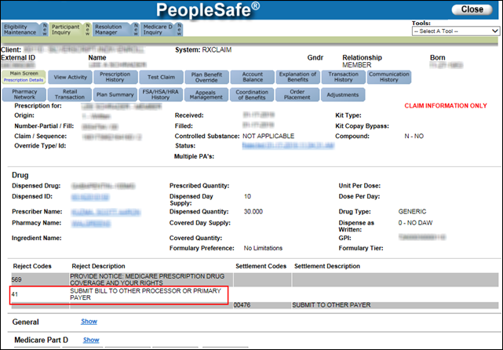

- Reject 819 – Medicare as Primary
  - This reject occurs because other insurance is being billed, but it is not in our system.
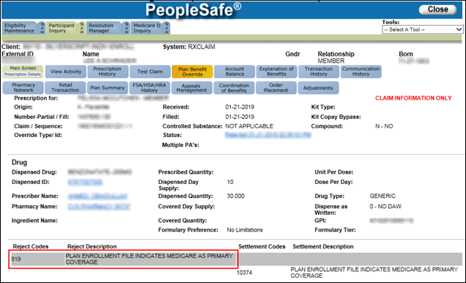

Note: If a Senior Rep is adding/removing the Alternate Insurance Flag in RXCADS1A due to Reject 41 or Reject 819 or if the beneficiary is disputing, it is their responsibility to take over the call as a Procedural Transfer and submit the RM Task to COB team for research.

Perform the following steps:
Step | Action
1 | To determine if MED D is listed as primary or secondary for a beneficiary in PeopleSafe, the CCR will review the Coordination of Benefits tab on the Main screen (Participant Inquiry tab).  Note: There can be multiple lines of coverage, select the line that the beneficiary is calling about.  Example 1. Other coverage is PRIMARY to Med D:  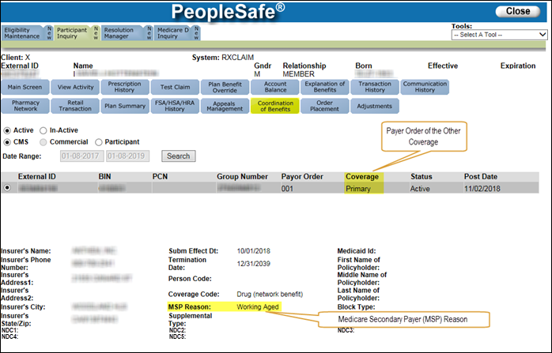  Example 2. Other coverage is SECONDARY to Med D:  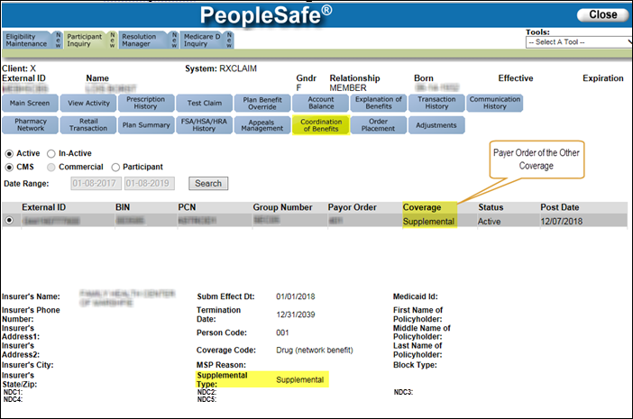
2 | Determine the MSP Reason.
2 | If the Reason is... |  |  |  |  |  |  | Then...
2 | - A = Working Aged  - G = Disabled  - B = ESRD |  |  |  |  |  |  | Proceed to Step 3.
2 | - D=Auto Ins/No Fault  - E=Workers Compensation  - L=Liability |  |  |  |  |  |  | Proceed to Step 4.
3 | Follow this step when other coverage is PRIMARY. MSP Reason A, G, or B.  - A = Working Aged  - G = Disabled  - B = ESRD  Our records indicate that you have another coverage, along with your MED D coverage, which is your primary payer coverage (insurance which should pay first) for your prescriptions.
3 | If the beneficiary says… |  | Then the CCR will…
3 | Yes, I do have another prescription coverage |  | - For MED D to be able to process other coverage as primary, the alternate insurance has to be Y.  - Advise the beneficiary/pharmacy to run the prescription again to the other coverage as the primary payer. Once the pharmacy runs the prescription with the other coverage as primary, then they can run the claim through the Part D Services system (as the secondary payer).
3 | Yes, I have other prescription coverage, but Medicare Part D is primary |  | Review the CIF in theSource, under Coordination of Benefits to determine if the senior team handles removing the Alternate Insurance Flag for the Beneficiary’s plan.  Note: Turn Around Time will vary.  Do NOT flip/remove the alternate insurance flag on the beneficiary’s secondary account. The alternate insurance flag should only be removed on the beneficiary’s primary account if the beneficiary no longer has any other prescription coverage.
3 |  |  | If... |  |  | Then...
3 |  |  | Yes |  |  | Warm transfer the call to Senior Team as a Procedural Transfer.  Refer to MED D - When to Transfer Calls to the Senior Team.  The Senior Rep will take over the call, remove the alternate insurance flag, and submit an RM task to the COB team for further research.  Task Category: Billing/Payment  Task Type: Premium Billing Inquiry Medicare D  Queue: Finance – Scottsdale Premium Billing  Amount Disputed: “0000”  Reason for Dispute: Coordination of Benefits  Include the following verbiage and information within the Beneficiary Comments.  - Reject COB Issue  - Provide an explanation of the issue  - Add Other Coverage, Update COB Coverage, Add Primary Coverage, or Add Secondary Coverage  - Include the Other Health Information to be updated (ID, BIN, PCN, GROUP, Insurance Name, Effective Date and/or term date of Coverage.)  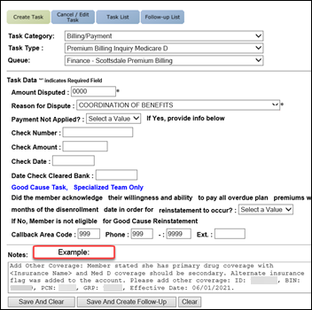
3 |  |  | No |  |  | Direct the beneficiary to the appropriate resource based on the CIF then proceed to Step 4.
3 | - No, I DO NOT have any other prescription coverage and I need my medication  OR  - I used to have other coverage but not anymore and I need my medication |  | Review the CIF in theSource, under Coordination of Benefits to determine if the senior team handles removing the Alternate Insurance Flag for the Beneficiary’s plan.  Note: Turn Around Time will vary.  Do NOT flip/remove the alternate insurance flag on the beneficiary’s secondary account. The alternate insurance flag should only be removed on the beneficiary’s primary account if the beneficiary no longer has any other prescription coverage.
3 |  |  | If... |  | Then...
3 |  |  | Yes |  | Warm transfer the call to Senior Team as a Procedural Transfer.  Refer to MED D - When to Transfer Calls to the Senior Team.  The Senior Rep will take over the call, remove the alternate insurance flag, and submit an RM task to the COB team for further research.  Task Category: Billing/Payment  Task Type: Premium Billing Inquiry Medicare D  Queue: Finance – Scottsdale Premium Billing  Amount Disputed: “0000”  Reason for Dispute: Coordination of Benefits  Include the following verbiage and information within the Beneficiary Comments.  - Reject COB Issue  - Provide an explanation of the issue  - Remove Other Coverage  - Include the Other Health Information to be updated (ID, BIN, PCN, GROUP, Insurance Name, Effective Date and/or term date of Coverage.)  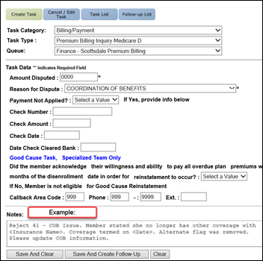
3 |  |  | No |  | Direct the beneficiary to the appropriate resource based on the CIF then proceed to Step 5.
4 | Follow this step when other coverage is PRIMARY. MSP Reason D, E, or L.  - D=Auto Ins/No Fault  - E=Workers Compensation  - L=Liability  In these instances, the medications are being covered are related to a specific incident and injury and should be completely covered by the other payer, with no copay remaining.  Our records indicate that you have another coverage, along with your MED D coverage, which is your primary payer coverage (insurance which should be pay first) for your prescriptions.
4 | If the beneficiary says… |  |  | Then the CCR will…
4 | Yes, I do have another prescription coverage |  |  | - The alternate insurance will not show as Y.  - Advise the beneficiary/pharmacy to run the prescription again to the other coverage as the primary payer. Pharmacy should only run the prescription with the other payer. DO NOT run the claim through the Part D Services system (as the secondary payer).  - Proceed to the next step.  Note: If the other coverage is not found in our system, warm transfer the call to Senior Team as a Procedural Transfer.  Refer to MED D - When to Transfer Calls to the Senior Team.  The Senior Rep will take over the call, add the alternate insurance flag, and submit an RM task to the COB team for further research.  Task Category: Billing/Payment  Task Type: Premium Billing Inquiry Medicare D  Queue: Finance – Scottsdale Premium Billing  Amount Disputed: “0000”  Reason for Dispute: Coordination of Benefits  Include the following verbiage and information within the Beneficiary Comments.  - Reject COB Issue  - Provide an explanation of the issue  - Add Other Coverage, Update COB Coverage, Add Primary Coverage, or Add Secondary Coverage  - Include the Other Health Information to be updated (ID, BIN, PCN, GROUP, Insurance Name, Effective Date and/or term date of Coverage.)
4 | - No, I DO NOT have any other prescription coverage and I need my medication  OR  - I used to have other coverage but not anymore and I need my medication |  |  | Review comments in PeopleSafe (including the specific medications that may be covered under other plan) and advise the beneficiary to have the pharmacy process the claim to the primary payer.  - If PeopleSafe comments indicate the drug is covered by alternate insurance, advise the beneficiary/pharmacy to process the claim to the primary payer.
4 |  |  |  | If... |  |  | Then...
4 |  |  |  | Non-Urgent |  |  | If no comments are found or beneficiary disputes the medications on comments – warm transfer the call to Senior Team as a Procedural Transfer.  Refer to MED D - When to Transfer Calls to the Senior Team.  The Senior Rep will take over the call and submit a request to the COB team through RM Task to research/update the COB information using the following option:  Task Category: Billing/Payment  Task Type: Premium Billing Inquiry Medicare D  Queue: Finance – Scottsdale Premium Billing  Amount Disputed: “0000”  Reason for Dispute: Coordination of Benefits  Include the following verbiage and information in the Beneficiary Comments:  - Reject COB Issue  - Provide an explanation of the issue  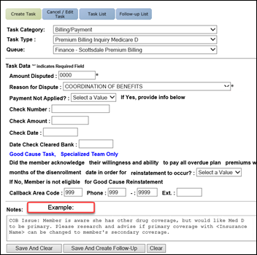  DO NOT remove Alternate insurance flag. COB Team will research and update accordingly.  - Proceed to the next step.
4 |  |  |  | Urgent |  |  | Warm transfer to the Senior Team as a Procedural Transfer.  Refer to MED D - When to Transfer Calls to the Senior Team.  The Senior Team will:  - Submit an email to COB.Operations@CVSHealth.com with ACCESS TO CARE - SECUREMAIL in the subject line and CC’ the Solon Senior Follow-Up Team SolonSeniorFollowupT@cvscaremark.com.  - In order to ensure a follow up call, warm transfer to the Case Coordinator Line 855-771-9283.  - Turn Around Time will vary.
5 | Ask if there are any other benefit questions.
5 | If... | Then...
5 | Yes | Address any questions.  Document and close the call according to current policies and procedures.  Refer to the MED D - Call Documentation work instruction.
5 | No | Document and close the call according to current policies and procedures.  Refer to the MED D - Call Documentation work instruction.

Top of the Document

Related Documents
Grievance Standard Verbiage (for use in Discussion with Beneficiary) section in MED D - Grievances Index

Parent SOP: CALL-0048: Medicare Part D Customer Care Call Center Requirements-CVS Caremark Part D Services, L.L.C.
Abbreviations/Definitions: Abbreviations / Definitions

Top of the Document

Not to Be Reproduced or Disclosed to Others without Prior Written Approval
ELECTRONIC DATA = OFFICIAL VERSION – PAPER COPY = INFORMATIONAL ONLY

